Rymabyeva Anelya, 2 course, Lab1 – IT Infrastructure and Networks

1. Use a console connection to access each switch.
2. Name **Room-145** and **Room-146** switches.

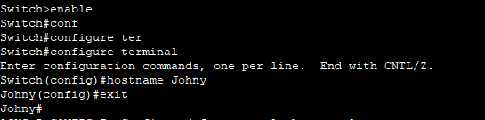

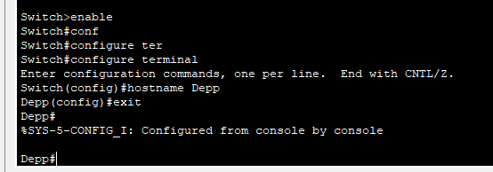

1. Use the **qwerty123**password for all lines.

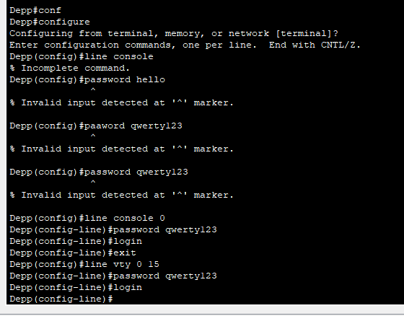

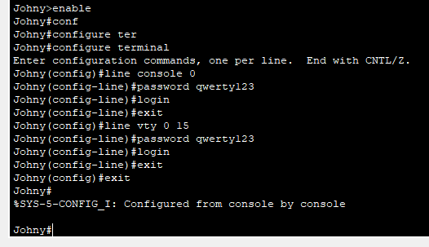

1. Use the **6EBUp** secret password.





1. Encrypt all clear text passwords.



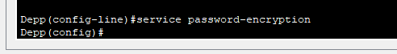

1. Configure an appropriate message-of-the-day (MOTD) banner.





1. Configure addressing for all devices according to the Addressing Table.

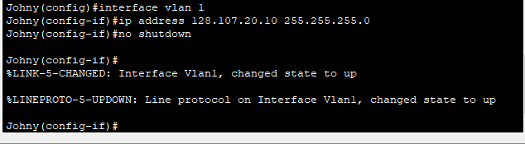

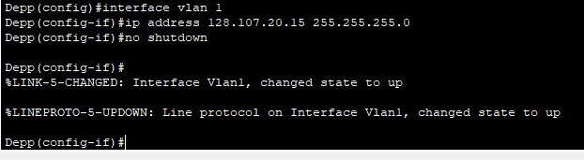

1. Save your configurations.

